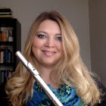  About the Instructor  Rachel Taylor Geier, DMA  - DMA (Doctor of Musical Arts) – University of Minnesota-Twin Cities; Emphasis in Flute Performance and Historical Musicology  - MM (Master of Music) – San Francisco State University; Music Performance  - BM (Bachelor of Music) – DePauw University; Music Performance  - Former Principal Flute, Camellia Symphony, Sacramento  - Private Flute Instructor – 20 years’ experience  - Freelance Flutist – Davis/Sacramento |  | davis arts center  Day & Time:  Wednesday, 7-9pm  Price:  $100 member  $110 non-member  Session A: 1/17-3/7  Session B: 4/4-5/23
  How to Register
  About Us
  Please visit http://www.davisartscenter.org/education/ to register online. You may also register over the phone by calling (530) 756-4100 or by submitting a class registration form to Davis Arts Center, PO Box 4340, Davis, CA 95617 or via fax to (520) 756-3041.
  Contact Us
  Davis Arts Center
  Phone: 530-756-4100
  Email: office@davisartscenter.org
  Web: www.davisartscenter.com
  
  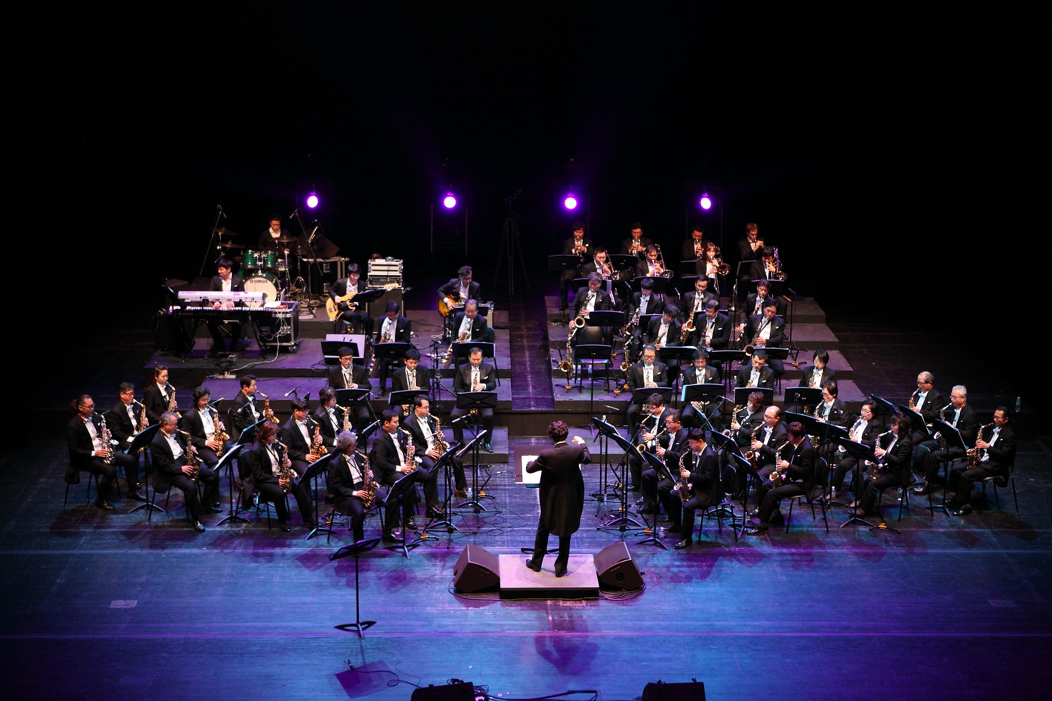
  Stage stories
    - Instructor:
    - Dr. Rachel Taylor Geier
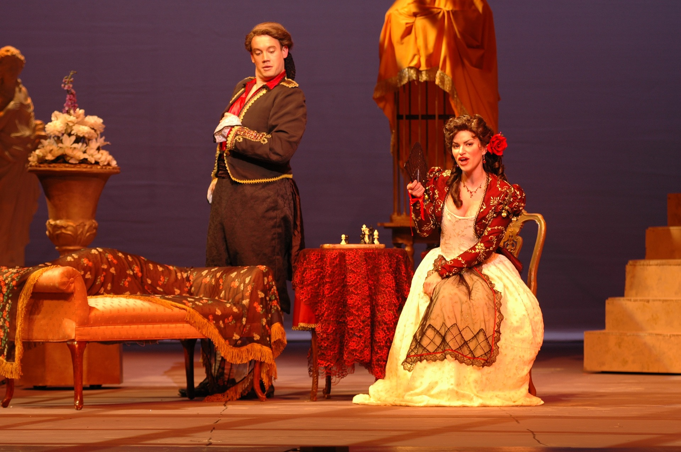  Stage Stories  Exploring Classical Music  About the Course  What is playing on your iPod right now? Taylor Swift? Drake? Pharrell? What is the song about? Does it tell a story? Chances are, it does. Have you ever thought about how these songs tell their stories through organization and form? Did you know that today’s popular music is based on forms and structures found in classical music? Pop, Rock, Jazz, Opera and Classical music all share one unifying theme – they are a type of storytelling. Some pieces use words, some use conversations, and some simply use music to suggest imagery that dares an audience to dream of their own meanings. | You do not need to have a background in music to succeed in this course. Anyone can read about, write about, listen to, and explore the same stories through music.  In this course, we will explore how classical music tells a story. For example, the music in an opera accentuates dramatic and narrative elements such as characters, places, and objects. A symphony doesn’t have a script, but helps us to imagine far off worlds using musical landscapes and conversations between groups of instruments. An instrumental concerto creates an opera without words using soloist narration and orchestral  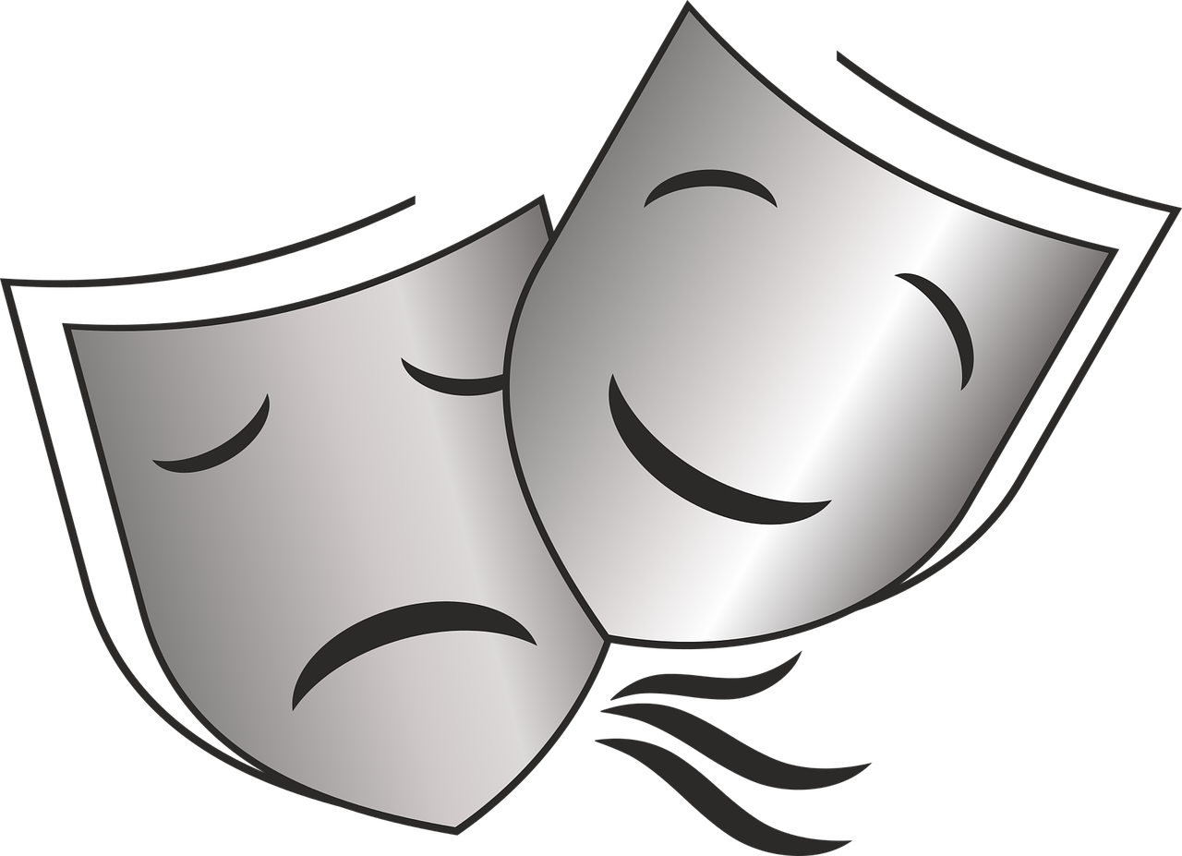 | 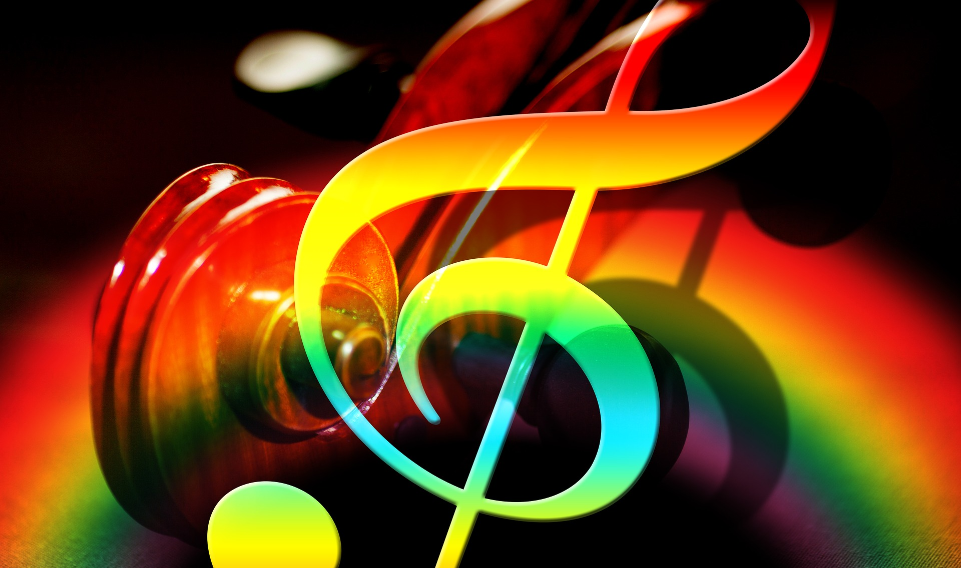  commentary. We will consider these aspects of musical expression by listening to works such as Rossini’s comic opera, The Barber of Seville, Beethoven’s famous 9th Symphony and Mozart’s Concerto for Flute and Orchestra in D Major. Most importantly, we will gain a greater appreciation for the power that classical music has to tell stories through sound.  A single piece can speak to different people in powerfully individual ways. This is a rare opportunity to experience classical music for yourself and to analyze music through listening, writing, and connecting stories to sound. You will leave this course with a new understanding of how all music, from Bach to Demi Levato, creates narratives with and without words.

